24 Port 1U Rackmount CAT6 UTP Patch Panel Plus Back Bar (PPAN-24-C6-BB)
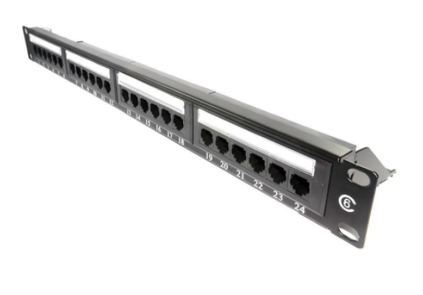

Description:
The LMS Data PPAN-24-C6-BB is 24 Port certified CAT6 UTP Patch Panel which is ideal for structured cabling installations in offices of all sizes. Slim line, 1U height means its ideal for small wall cabinets as well as regular, floor standing cabinets and racks. Also incorporated is a removable rear cable management bar to provide effective cabling anchoring.

Fully Gigabit Ethernet certified means its ideal for running legacy and advanced networking protocols to Gigabit Switches up up to 1000Mbps. Also ideal for telecom, VoIP, CCTV-IP and other Ethernet based standards.

Long-life, nickel plated female RJ45s, robust construction with colour-coded rear Krone(tm) KATT type IDC for both TIA-568A/B terminations.

Looking for an economical but effective unshielded (UTP) Category 6 patch panel solution for your network? The new LMS Data PPAN-24-C6-BB offers performance Category 6 performance for your current and next generation networking applications, for gigabit ethernet and advanced telco applications for example. Industry standard, dual-personality IDC punchdown for Krone(tm) and 110 tooling, clear colour coding for true TIA/ EIA compliance and long life RJ45 UTP ports. Part of the LMS Data 25-year warranty system*, the PPAN-24-C6-BB is your ideal patching solution for warranted and un-warranted current and next generation networking, telco and server applications - at a competitive price point.

Key Features:
- Certified CAT6 Performance for Gigabit Ethernet
- Popular Krone(tm) KATT Dual Purpose IDC Punchdown
- Removable Rear Cable Management Bar for Cable Anchoring
- Part of the Synthesis 25-Year Warranty Solution

Specifications
- 24-Port, 19-inch wide category 6 patch panel
- Unshielded (UTP) RJ45 Ports, numbered
- 1U Form factor with rear management bar
- Exceeds current Category 6 performance
- TIA-EIA-568A/B2.1with Krone(tm) & 110 IDC
- Phosphor bronze and Nickel IDC connectors
- Robust UTP RJ45 ports for extended lifespan
- Supports 22 to 26 AWG conductor diameters
- Additional labelling area for bespoke identification

Applications:
- Office, Education and Home Structured Cabling Installs
- Ideal for Gigabit Ethernet (1000Mbps) Data Networks
- Create fault tolerant LANs by simply patching ports

Product Code:
- Part Number: PPAN-24-C6-BB
- EAN: 8400800032164
- Weight: 0.5Kg approx.

Technical Specifications:
- Port Count : 24 Ports UTP
- Dimensions:1U 19-Inch Design Format
- Conformance:TIA-EIA-568A/568-B2.1 Coded IDC
- Performance:10/100/1000Mbps Gigabit Compliance
- RJ45/IDC Connects: Nickel and Phosphor Bronze
- Port Identification:Numbered and Bespoke ID Marker
- Fixings:Supplied M6 Nuts and Bolts
* Specifications and product design are subject to change. E&OE.

